## **AWS Assignment 9: Configure AWS CLI, SDK and Boto**

### **Configure AWS CLI**

Submit AWS CLI commands for below requirement:

1. Create a S3 Bucket

**aws s3 mb s3://awscli321**

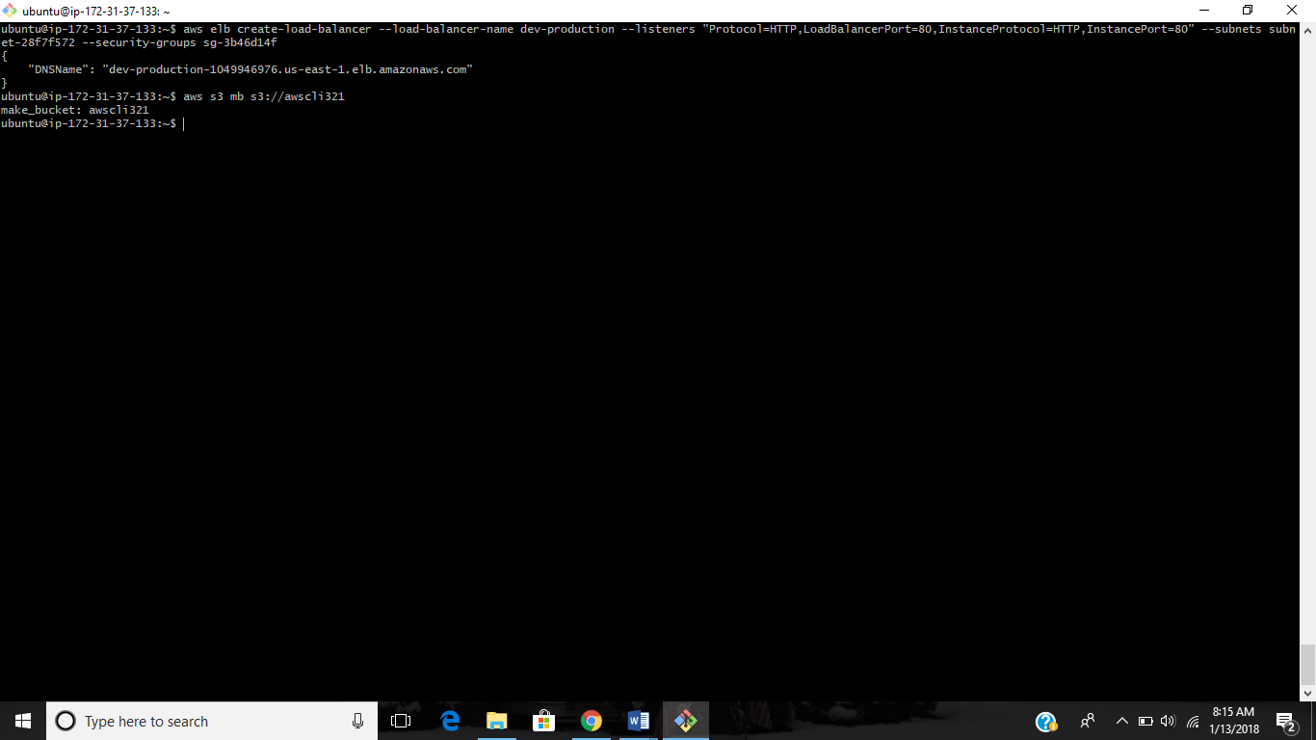

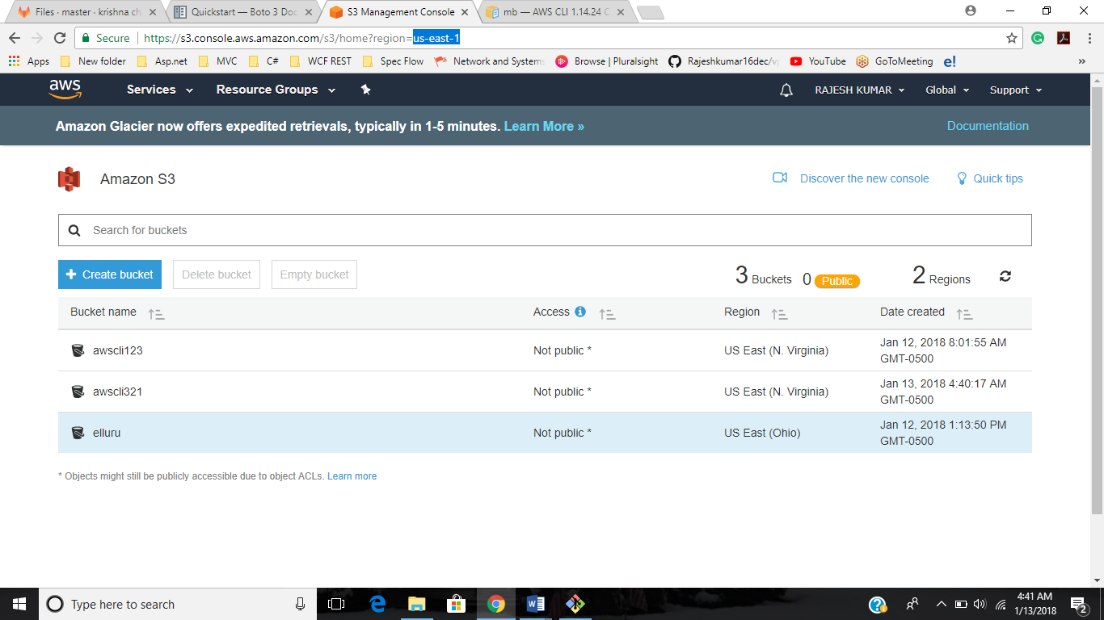

1. Deleting S3 Bucket

**aws s3 rb s3://awscli321**

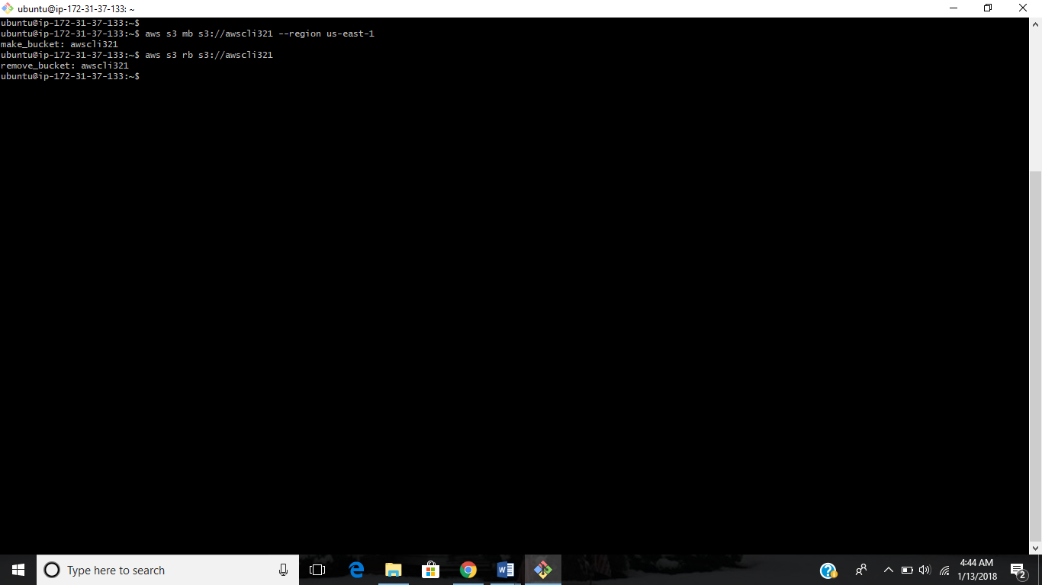

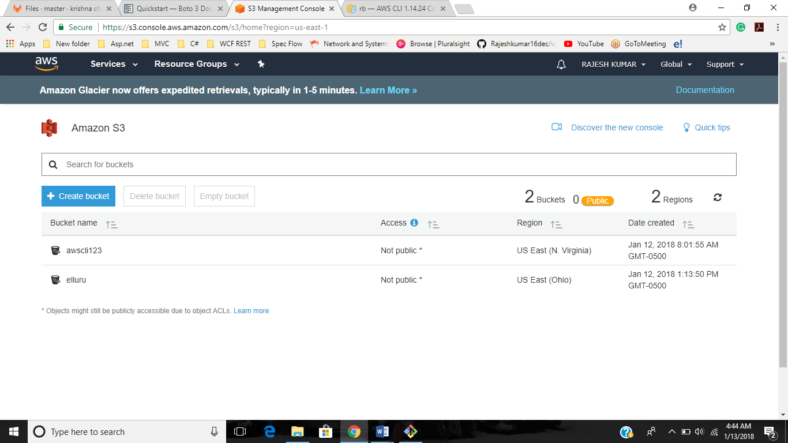

1. Listing contents of S3 Bucket

**aws s3 ls s3://awscli123**

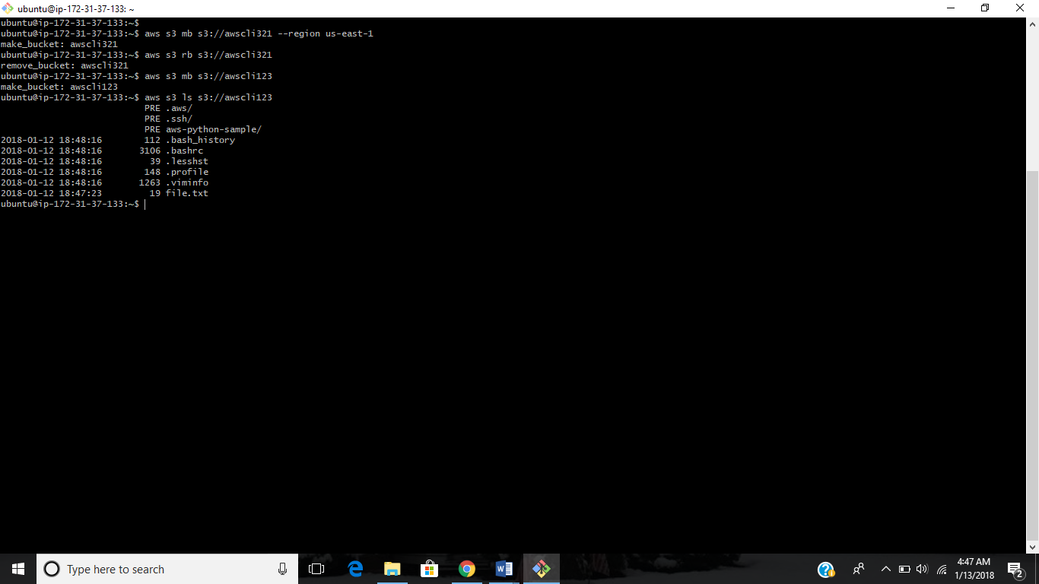

1. Creating a EC2 instance

aws ec2 run-instances --image-id ami-41e0b93b --count 1 --instance-type t2.micro --key-name Ansible --security-group-ids sg-26993d52

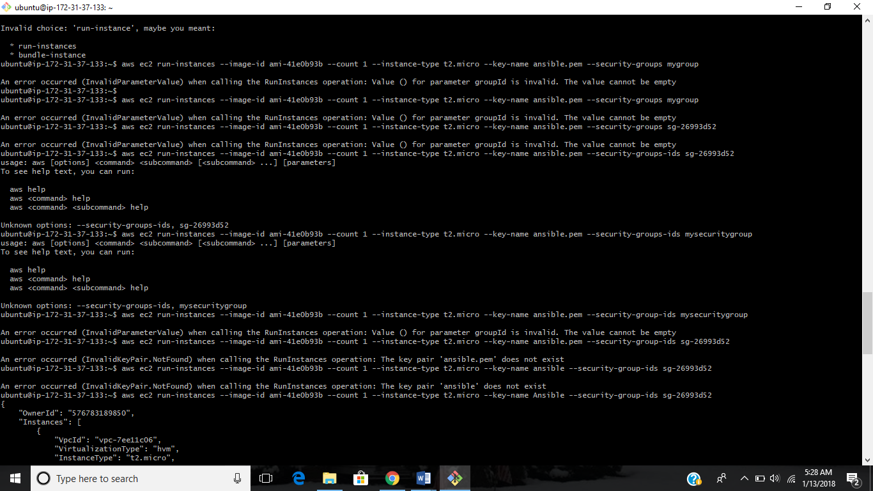

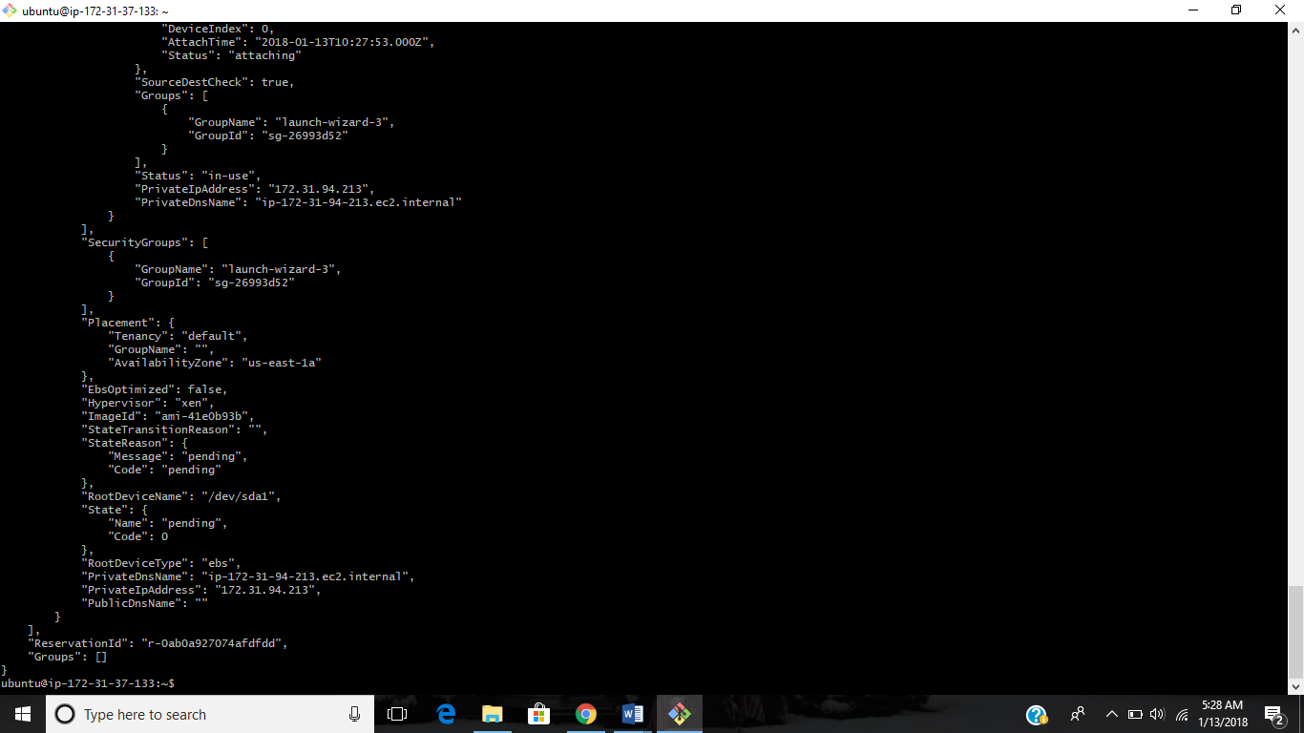

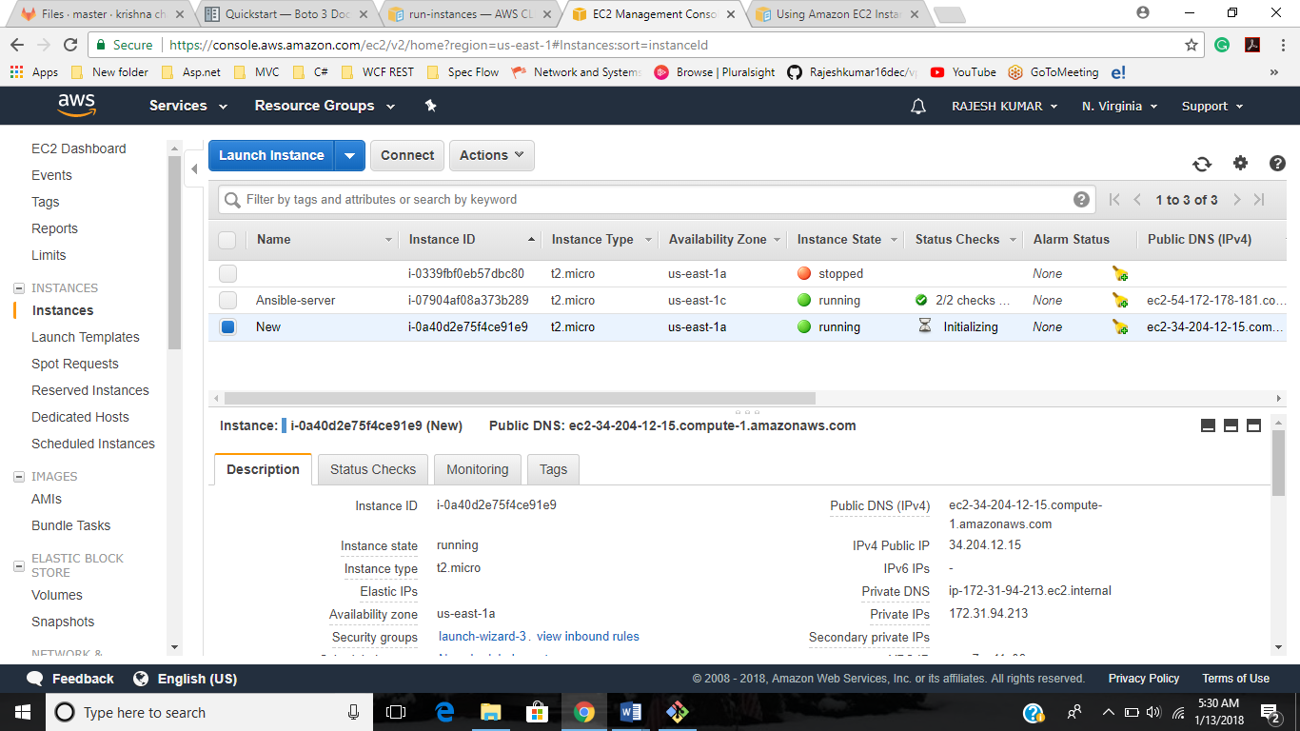

1. Copy a file from local to S3

aws s3 cp new.txt s3://awscli123/test.txt

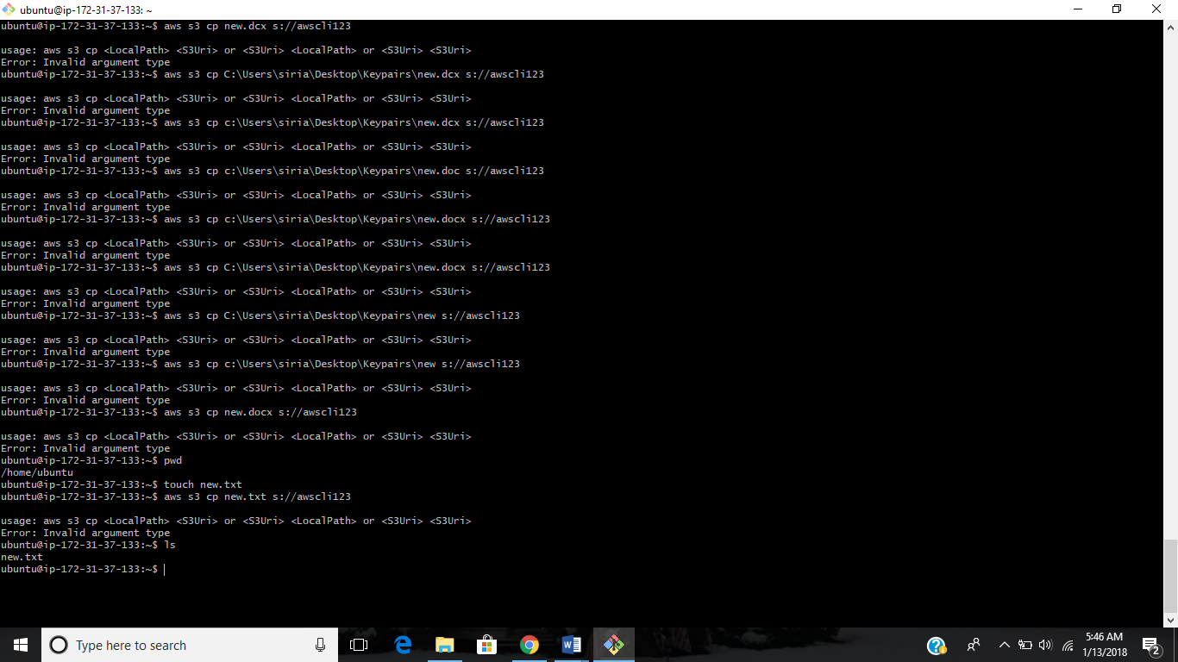

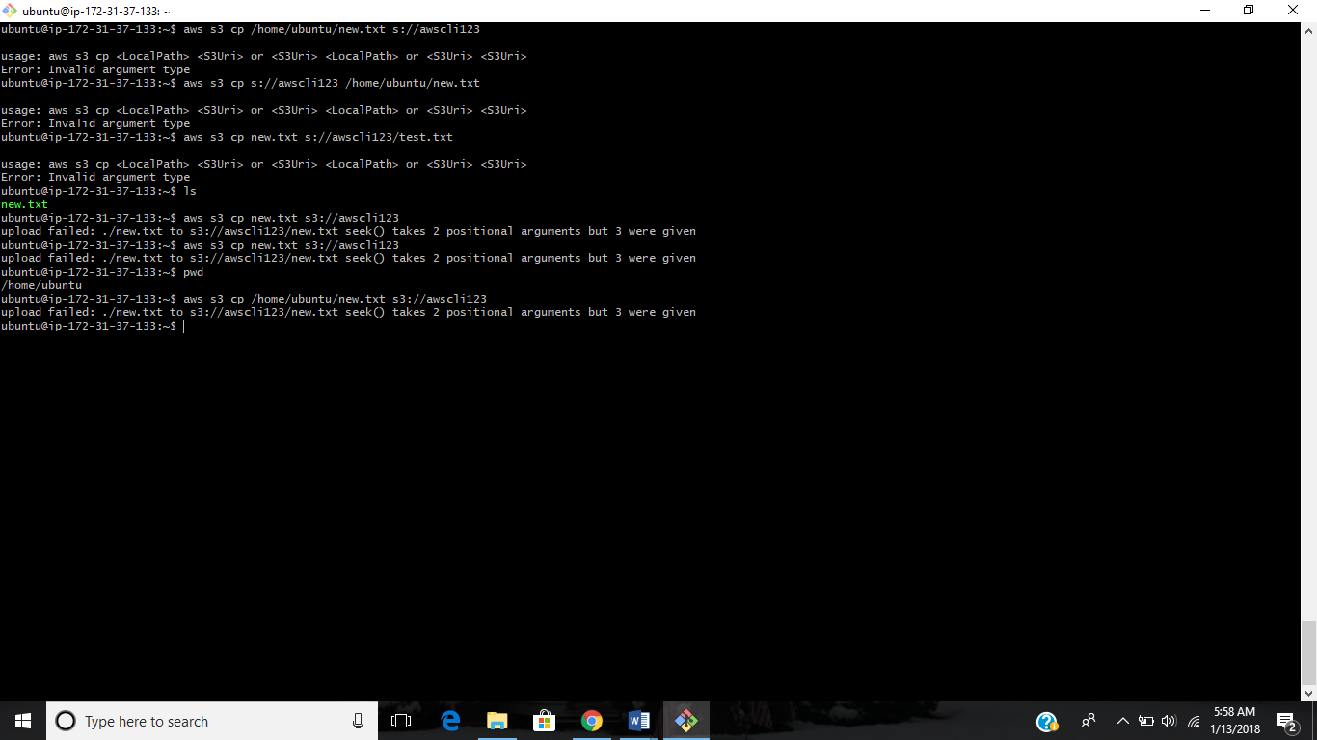

1. Create a RDS instance

aws rds create-db-instance --db-instance-identifier sg-cli-test --allocated-storage 20 --db-instance-class db.m1.small --engine mysql --master-username rajesh --master-user-password kumarkumar

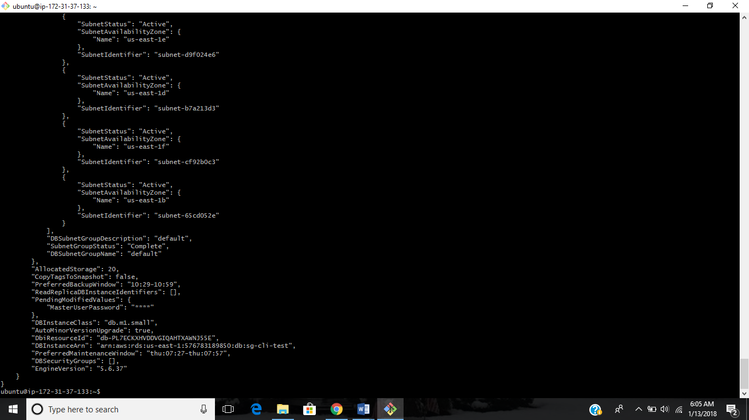

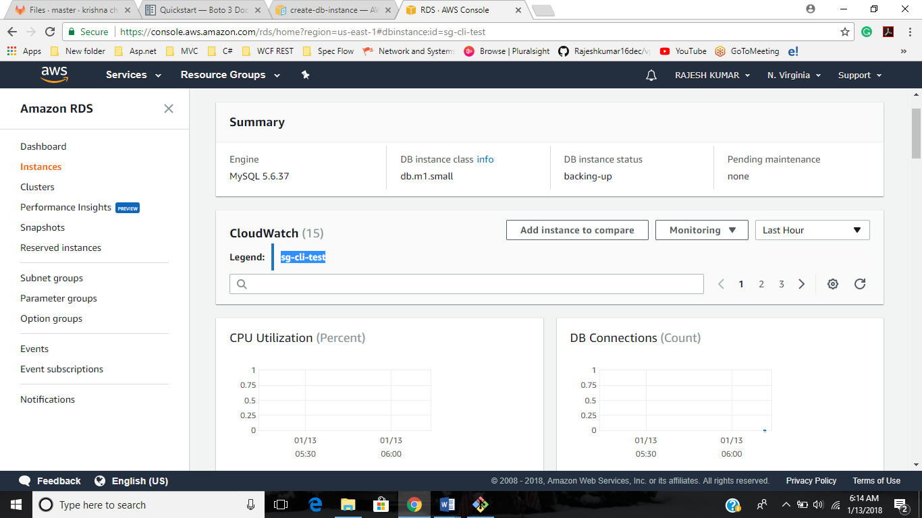

1. Creating a Snapshot for EBS and RDS.

aws ec2 create-snapshot --volume-id vol-080748864c5272adf --description "rootvolume2"

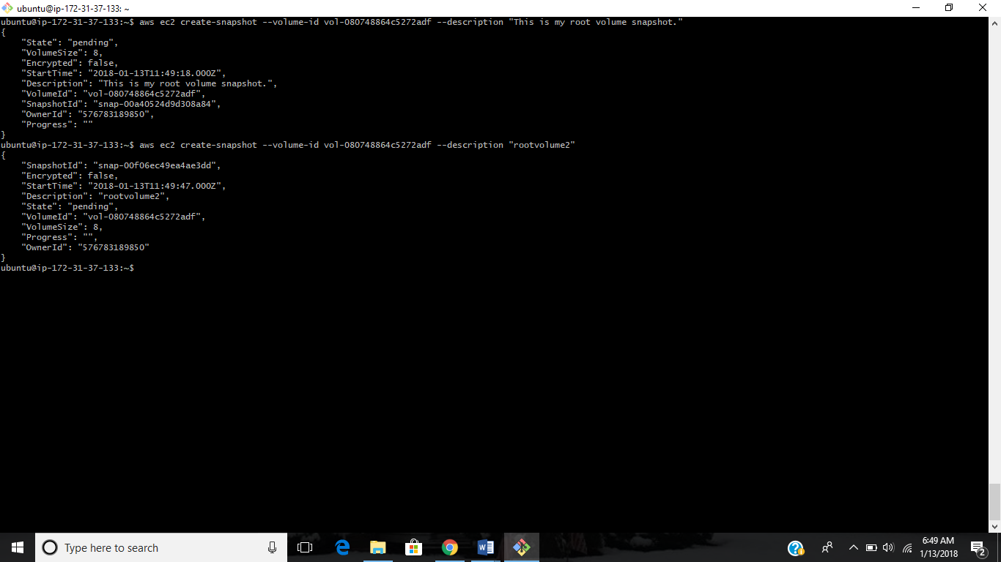

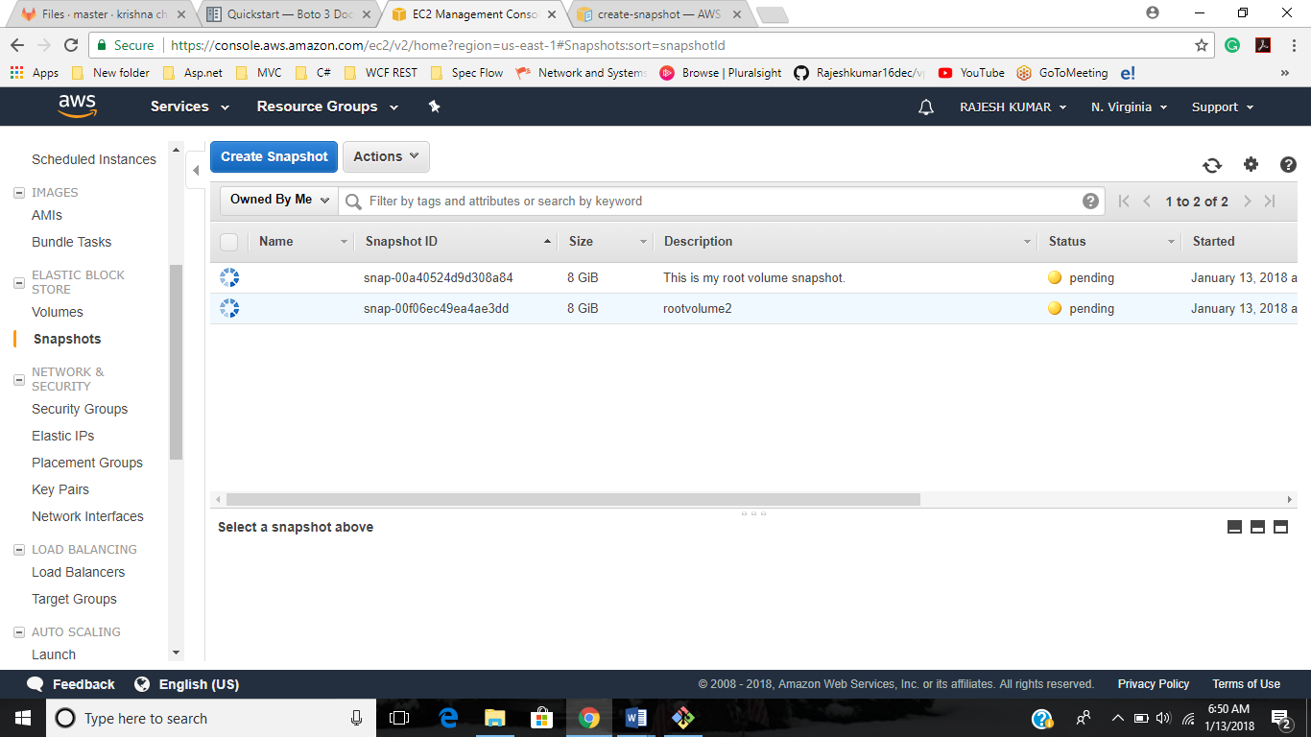

1. Create a IAM user

aws iam create-user --user-name kumar

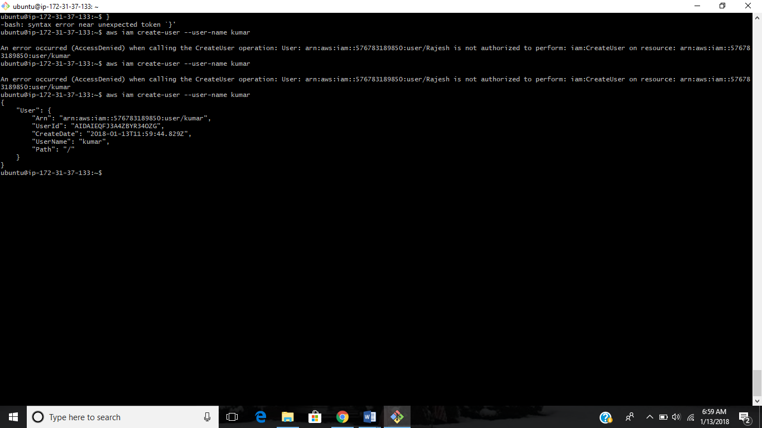

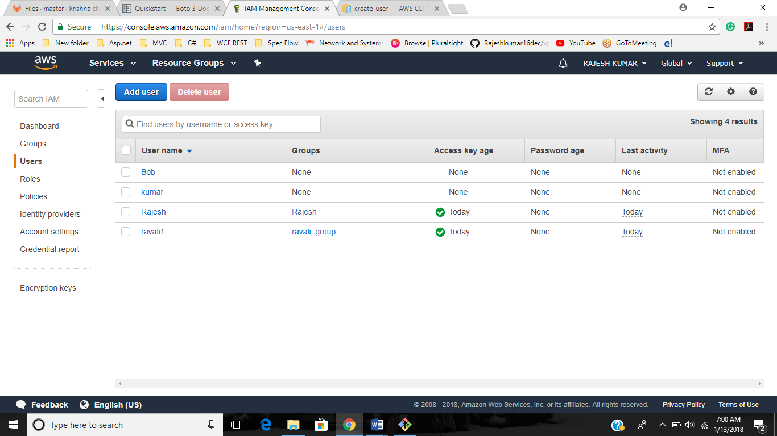

1. Stop/Terminate a EC2 instance

aws ec2 stop-instances --instance-ids i-0339fbf0eb57dbc80

aws ec2 terminate-instances --instance-ids ID i-0339fbf0eb57dbc80

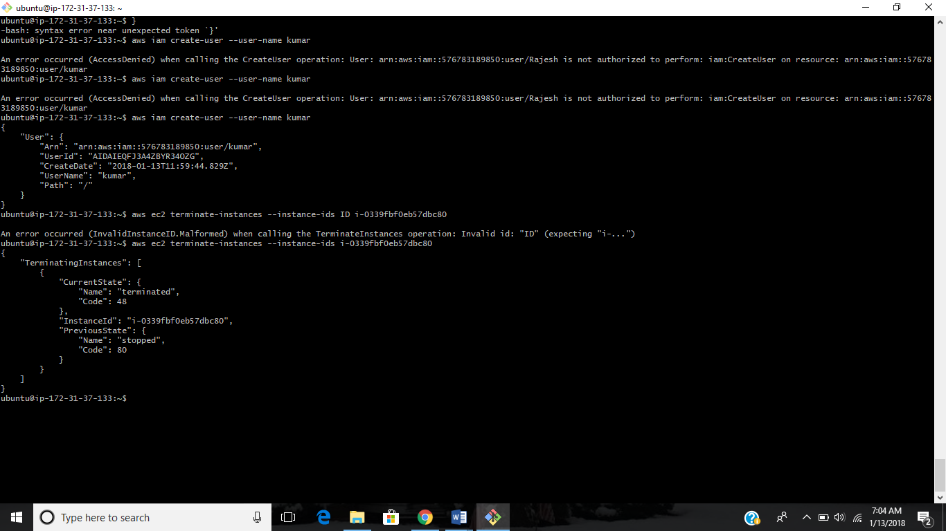

1. Create a EC2 Classic Load Balancer

**aws elb create-load-balancer --load-balancer-name dev-production --listeners "Protocol=HTTP,LoadBalancerPort=80,InstanceProtocol=HTTP,InstancePort=80" --subnets subnet-15aaab61 --security-groups sg-a61988c3**

